CN Lab Session 3

Name: Paawan Kohli
Reg No: 180905416

Question 1:

Topology:
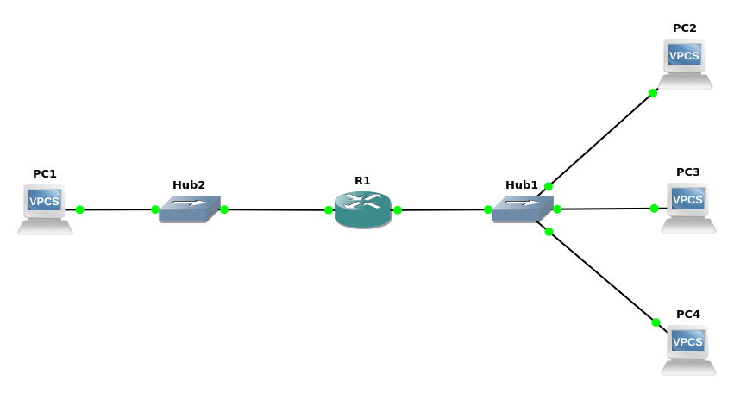
Conf:

interface F0/0 in router1:
enable
conf t
int f0/0
ip address 10.0.1.1 255.0.0.0
no shutdown
exit
exit
write

interface F0/1 in router1:
enable
conf t
int f0/1
ip address 10.0.2.138 255.255.255.0
no shutdown
exit
exit
write

check interfaces
show interfaces

Pings from PC1:
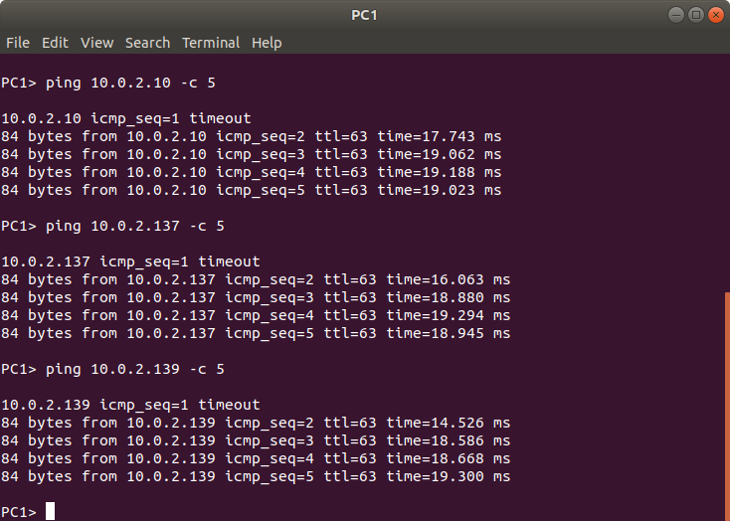
Wireshark:

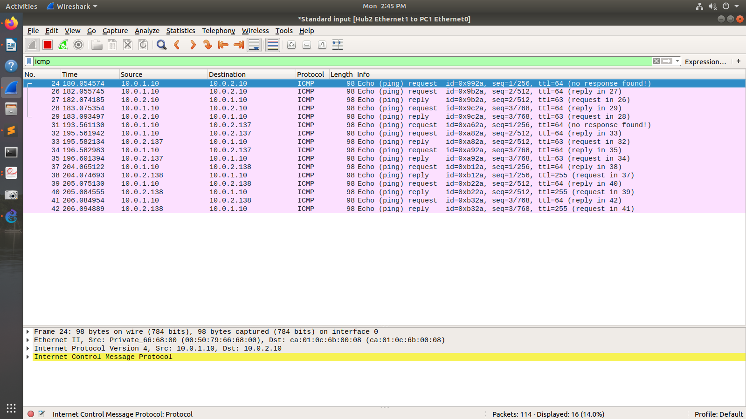
Show arp on pc1:

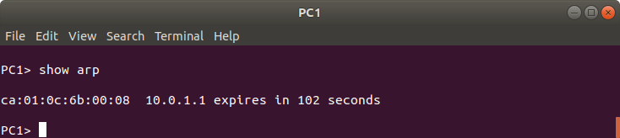
Show arp on pc2:

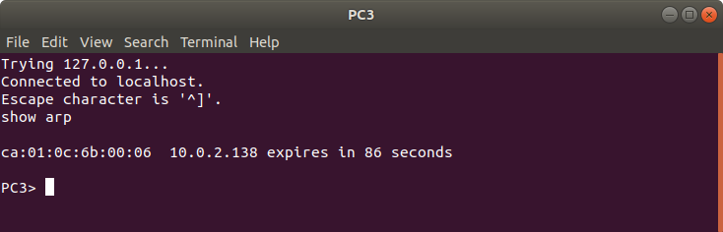

Routing table:

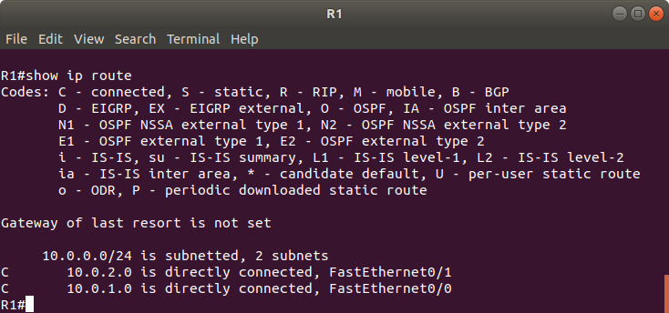

Question 2:

There are 256 addresses in this block. the first address is 14.24.74.0/24; The last address is 14.24.74.255/24.

The number of addresses in the largest subblock ,which requires 120 addresses, is not power of 2, we allocate 128 addresses .The subnet mask for this subnet = 25. The first address in this block is 14.24.74.0/25 and the last address is 14.24.74.127/25.

The number of addresses in the second largest subblock, which requires 60 addresses , is not a power of 2 either, so we allocate 64 addresses .The subnet mask for this subnet = 26. The first address in this block is 14.24.74.128/26 and the last address is 14.24.74.191/26

The number of addresses in the smallest subblock ,which requires 10 addresses, is not a power of 2 so we allocate 16 addresses.The subnet mask for this subnet = 28. The first address in this block is 14.24.74.192/28 and the last address is 14.24.74.207/28

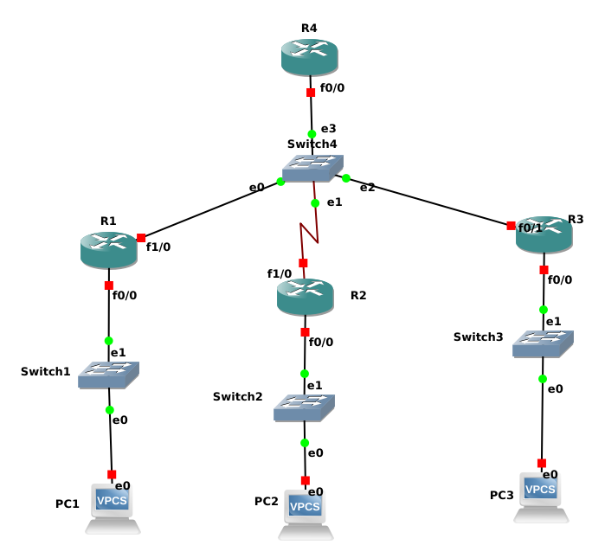
Setting up ip address, mask and deafult gateway for pc1, pc2 and pc3:

PC1> ip 14.24.74.194/28 14.24.74.193
Checking for duplicate address...
PC1 : 14.24.74.194 255.255.255.240 gateway 14.24.74.193

PC2> ip 14.24.74.130/26 14.24.74.129
Checking for duplicate address...
PC1 : 14.24.74.130 255.255.255.192 gateway 14.24.74.129

PC3> ip 14.24.74.2/25 14.24.74.1
Checking for duplicate address...
PC1 : 14.24.74.2 255.255.255.128 gateway 14.24.74.1

Setting router interfaces :
R1:

R1#enable
R1#conf t

R1(config)#int f0/0
R1(config-if)#ip add 14.24.74.193 255.255.255.240
R1(config-if)#no shutdown
R1(config-if)#exit

R1(config)#int f1/0
R1(config-if)#ip add 10.0.1.1 255.255.255.0
R1(config-if)#no shutdown
R1(config-if)#exit

R1(config)#exit
R1#write

R2:

R2#enable
R2#conf t

R2(config)#int f0/0
R2(config-if)#ip add 14.24.74.129 255.255.255.192
R2(config-if)#no shutdown
R2(config-if)#exit

R2(config)#int f1/0
R2(config-if)#ip add 10.0.1.2 255.255.255.0
R2(config-if)#no shutdown
R2(config-if)#exit

R2(config)#exit
R2#write
R3:

R3#enable
R3#conf t

R3(config)#int f0/0
R3(config-if)#ip add 14.24.74.1 255.255.255.128
R3(config-if)#no shutdown
R3(config-if)#exit

R3(config)#int f1/0
R3(config-if)#ip add 10.0.1.3 255.255.255.0
R3(config-if)#no shutdown
R3(config-if)#exit

R3(config)#exit
R3#write
Building configuration...

Configuing static tables in routers R1, R2, R3

R1(config)#ip route 14.24.74.0 255.255.255.128 10.0.1.3
R1(config)#ip route 14.24.74.128 255.255.255.192 10.0.1.2

R2(config)#ip route 14.24.74.192 255.255.255.240 10.0.1.1

R3(config)#ip route 14.24.74.192 255.255.255.240 10.0.1.1

Q3 DHCP

Topology:

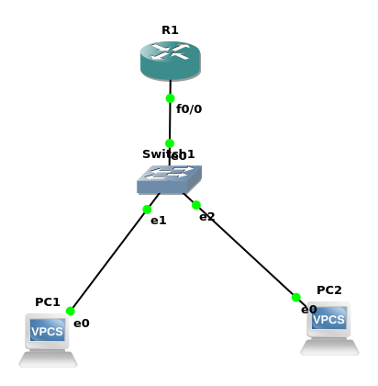

Router:

R1# enable
R1(config)# int f0/0
R1(config-if)# ip address 10.0.1.1 255.255.255.0
R1(config-if)# no shutdown
R1(config-if)# exit

R1(config)# ip dhcp pool lan1
R1(dhcp-config)# network 10.0.1.0 255.255.255.0
R1(dhcp-config)# Default-router 10.0.1.1
R1(dhcp-config)# exit
R1(config)# exit

On pc1 and pc2
dhcp

4. DHCP 2

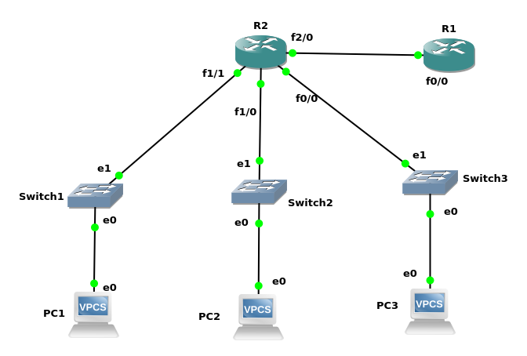

Confuguring R1 router as DHCP

R1#enable
R1#conf t

R1(config)#ip dhcp pool lan1
R1(dhcp-config)#network 10.0.1.0 255.255.255.0
R1(dhcp-config)#default-router 10.0.1.1
R1(dhcp-config)#exit

R1(config)#ip dhcp pool lan2
R1(dhcp-config)#network 10.0.2.0 255.255.255.0
R1(dhcp-config)#default-router 10.0.2.1
R1(dhcp-config)#exit

R1(config)#ip dhcp pool lan3
R1(dhcp-config)#network 10.0.3.0 255.255.255.0
R1(dhcp-config)#default-router 10.0.3.1
R1(dhcp-config)#exit

R1(config)#exit
R1#write

Setting next hop address on R1 :

R1#conf t

R1(config)#ip route 10.0.1.0 255.255.255.0 30.0.0.2
R1(config)#ip route 10.0.2.0 255.255.255.0 30.0.0.2
R1(config)#ip route 10.0.3.0 255.255.255.0 30.0.0.2

R1(config)#exit
R1#write

Setting R2 interface and helper address(i.e relay server to r1 for dhcp)

R2#enable

R2#conf t
R2(config)#int f2/0
R2(config-if)#ip add 30.0.0.2 255.255.255.0
R2(config-if)#ip helper-address 30.0.0.1
R2(config-if)#no shutdown
R2(config)#exit
R2#write

R2#conf t
R2(config)#int f1/1
R2(config-if)#ip add 10.0.1.1 255.255.255.0
R2(config-if)#ip helper-address 30.0.0.1
R2(config-if)#no shutdown
R2(config-if)#exit

R2(config)#int f1/0
R2(config-if)#ip add 10.0.2.1 255.255.255.0
R2(config-if)#ip helper-address 30.0.0.1
R2(config-if)#no shutdown

R2(config-if)#int f0/0
R2(config-if)#ip add 10.0.3.1 255.255.255.0
R2(config-if)#ip helper-address 30.0.0.1
R2(config-if)#no shutdown

R2(config-if)#int f2/0
R2(config-if)#ip add 30.0.0.2 255.255.255.0
R2(config-if)#no shutdown
R2(config-if)#exit
R2(config)#exit
R2#write

OUTPUT:

PC1> dhcp
DDORA IP 10.0.1.2/24 GW 10.0.1.1

PC3> dhcp
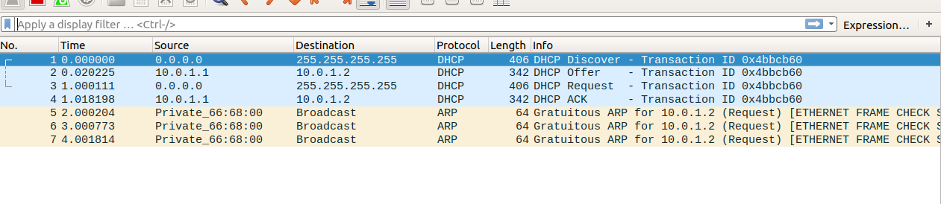
DDORA IP 10.0.3.2/24 GW 10.0.3.1

